P&C Uniform Shop
Moorooka State School
Sherley St, Moorooka. 4105
uniformshop@moorookass.eq.edu.au

The Uniform Shop operated by the Moorooka State School P&C Association is located at the front of the School Hall next
to the Tuckshop. During term the Uniform Shop is open each Friday afternoon from 2-4pm. Eftpos facilities are available.

PREP 2024 SCHOOL UNIFORMS

Dear 2024 Prep Parents / Guardians,

All Moorooka State School students are expected to wear the prescribed uniform as outlined in the school’s Uniform Policy. The school does not have a separate formal and sports uniform.

COMPULSORY UNIFORM

Year Round
- Royal Blue bucket or broad-brimmed hat with custom school embroidery
Hats must be worn in the playground at all times - No Hat, No Play!
- Royal Blue & Yellow polo shirt with custom school printing and
Royal Blue shorts or skort, or
- Checkered school dress with custom school embroidery
- Plain white socks# or white sockettes with custom school printing
- Black shoes/joggers with black laces or velcro straps or buckles#

Winter
- Dark Royal fleecy-lined jacket with custom school printing

OPTIONAL UNIFORM

- Royal Blue & Yellow long-sleeve polo shirt with custom school printing
Long-sleeve shirts were introduced to cater for students with sensitive skin and those whose
religious beliefs require full coverage of the arms. These are not a mandatory winter requirement.
- Black & Royal Blue Music short-sleeve polo shirt
Music shirts are required for choir, band members and musical soloists.
- Royal Blue long winter pants
- Black# or Dark Navy tights
- Any religious headwear must be solid Royal Blue, White or Black (no embellishments).

# Items not available from the Uniform Shop

Prep students do not swim in PE classes during Term 1, but they will need a swim cap for PE in Term 4. Lycra swim caps are available in house colours from the Uniform Shop.

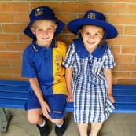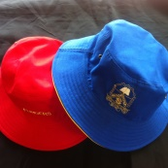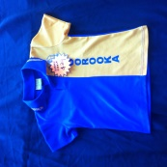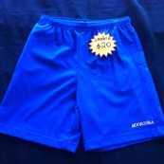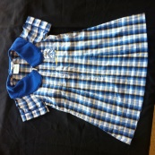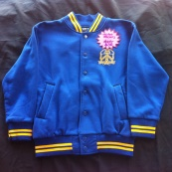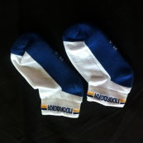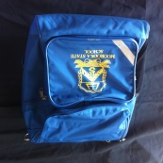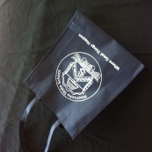

Every Prep Student
Enrolled for 2024
Gets a Free School Hat

This is a special gift from the Moorooka State School Parents & Citizens Association to welcome you to the school and promote sun safety. You will receive your reversible bucket hat in house colours on the first day of school 2024.

The school has three sports houses – Coggara (Royal Blue), Murree (Red) and Cabbul (Yellow). Houses will be assigned only once final enrolment numbers are known. Children with siblings at the school will be in the same house.

ORDERING ONLINE

You can purchase online at any time using Qkr! (pronounced Quicker). Simply download the free “Qkr! with Masterpass” app onto your mobile phone and register yourself. Select Moorooka State School and create a profile for each of your children. Select the items you want to purchase. Pay using your debit or credit card; you will be emailed a receipt.

Your BTS order will be picked and held at the Uniform Shop ready for you to collect anytime the Uniform Shop is open.

Qkr! is also used for online Tuckshop ordering and many other P&C events too, so it is very worthwhile becoming familiar with it.

ORDERING IN PERSON

The Uniform Shop is located at the front of the School Hall next to the Tuckshop. During term the Uniform Shop is open every Friday afternoon from 2-4pm. Eftpos facilities are available and we have two portable changerooms where children can try on items to ensure you purchase the correct size.

EXCHANGING SIZES

Prep students rarely require other than a Size 4 or Size 6. We encourage all new Prep parents to have their child try on items rather than guess their size. We will exchange items if you do happen to select the wrong size, however we ask you to take particular care, especially when ordering online to avoid the need for this.

2ND HAND UNIFORMS

The Uniform Shop no longer co-ordinates the sale of second-hand uniforms. The Moorooka State School
P&C Association has created a private Facebook group where parents are able to buy, sell and donate preloved Moorooka State School uniforms. This is a great way to top-up with a couple of extra uniforms and reduce that constant washing burden. Genuine MSS Uniform items only. Simply visit;

Moorooka SS Second-Hand Uniform’s Buy/Sell/Swap

2024 PREP UNIFORM CHECKLIST
(Most Prep Students are a Size 4 or Size 6)

Item | Price | Size/Qty | Notes
Royal Blue Reversible Bucket HAT  - size S | FREE  $18.00 |  | 1 x FREE courtesy of the Moorooka SS P&C
Royal Blue Broad Brimmed HAT  - size M, L | $16.00 |  | Alternative to Bucket Hat (not reversible)
Curly Hair Ties  - in school and house colours | $6.00 |  | Available in Royal Blue & Yellow,  Royal Blue, Red or Yellow
Unisex Royal Blue / Yellow  Short-sleeve POLO SHIRT  - sizes 4, 6 | $29.00
Unisex Royal Blue / Yellow  Long-sleeve POLO SHIRT  - sizes 4, 6 | $33.00 |  | For students requiring full coverage of the arms  for religious or skin sensitivity reasons
Unisex Black / Royal Blue  Short-sleeve MUSIC POLO SHIRT  - size 6 | $29.00 |  | Only required by choir or band members  and musical soloists, generally not Preppies
Unisex Royal Blue Rugby Knit SHORT  - sizes 3, 4, 6 | $19.00 |  | Size 3 is available for our smallest Preppies
Royal Blue HIPSTER SKORT  - sizes 4, 6 | $25.00
Royal Blue SPORT SKORT  with yellow piping  - sizes 4, 6 | $25.00
Moorooka SS Checkered DRESS  (alternative to Polo/Skort combo)  - sizes 4, 6, 8 | $50.00 |  | Current stock $48.00
White Moorooka SS SOCKETTES  - sizes 8-12, 13-3 | $8.00 / pair |  | Current stock $7.50/pr
Dark Navy TIGHTS  - sizes 3-5, 6-9 | $9.00 / pair  $16.00 / 2pk
Unisex Dark Royal WINTER JACKET  - sizes 4, 6 (Note: Very generous fit) | $36.00 |  | Preppies rarely need larger than a Size 4
Unisex Royal Blue Gabardine  LONG WINTER PANTS - Double-Knee  - sizes 4, 6 | $22.00 |  | Lightweight alternative to heavier fleece
Unisex Dark Royal Fleecy-lined  LONG WINTER PANTS - Double-Knee  - sizes 4, 6 | $24.00
Moorooka SS BACKPACK  - 25L curved top | $50.00 |  | Lifetime Manufacturer’s Defect Guarantee
Moorooka SS BACKPACK  - 23L flat top | $39.00 |  | 3yr Manufacturer’s Defect Guarantee
Lycra SWIM CAP  - in house colours | $6.00 |  | Available in Royal Blue, Red or Yellow
Yellow Silicone SWIM CAP  - with Moorooka MARLINS logo | $10.00

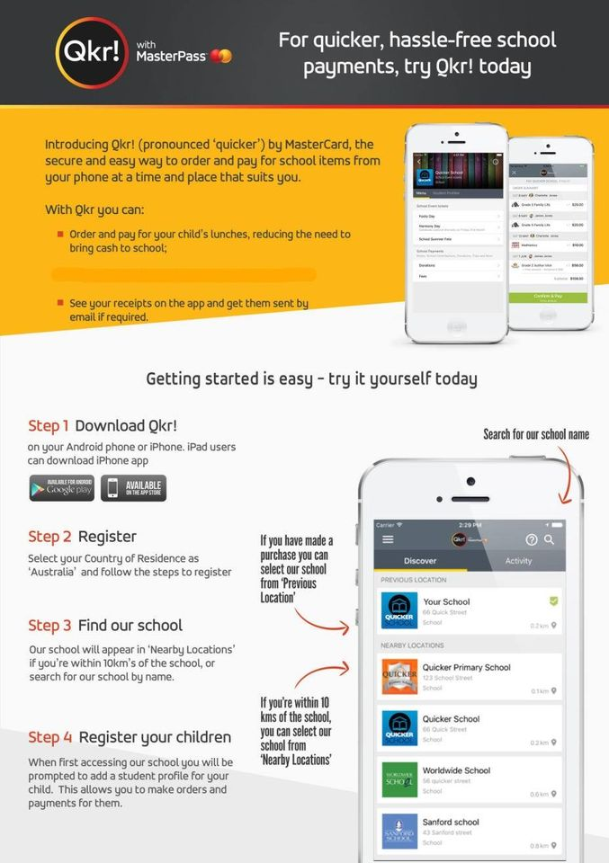
HOW TO REGISTER
& ORDER ONLINE

DOWNLOAD QKR! onto your Android phone, iPhone or iPad (it’s Free).

REGISTER (one time only)
Register as you, not your child.
Both parents can register separately.

Find Moorooka State School
Register your child/children

For 2023 Preppies please select;
Year: Prep
Class: Future Student

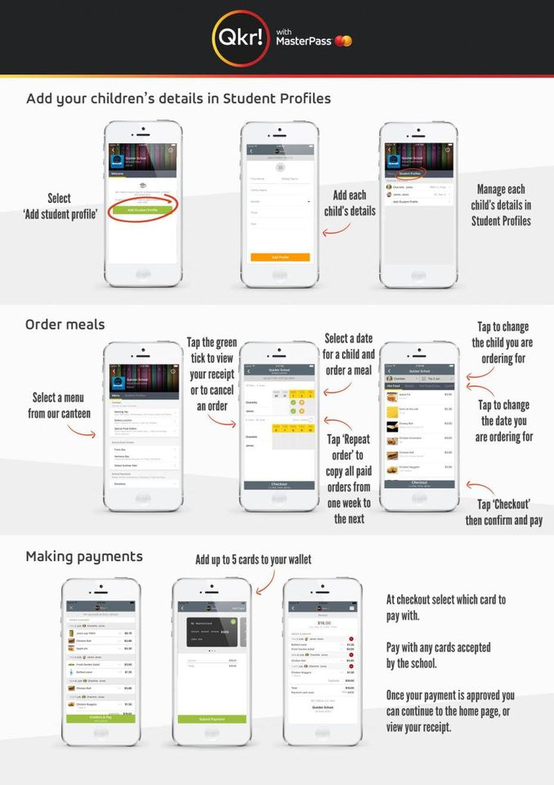
Select the UNIFORM SHOP to place order Uniforms

Orders can only be placed for supply in the current fortnight. BTS orders placed before the New Year will be picked and held for collection at the Uniform Shop under your child’s name. You will not be able to collect it from the School Office.

2023 Preppies do not need to order a Reversible Hat as it is provided Free by the P&C.

Select the Item you want to order making sure you choose the size and quantity for each Item before adding it to the cart.

If you want to order more than one size of an Item you will need to add both sizes to the cart separately.

